TASK 6 – Design the Inheritance Hierarchy
Student Name: B. Muni Chandini
Register Number: 192524283

1. Inheritance Hierarchy
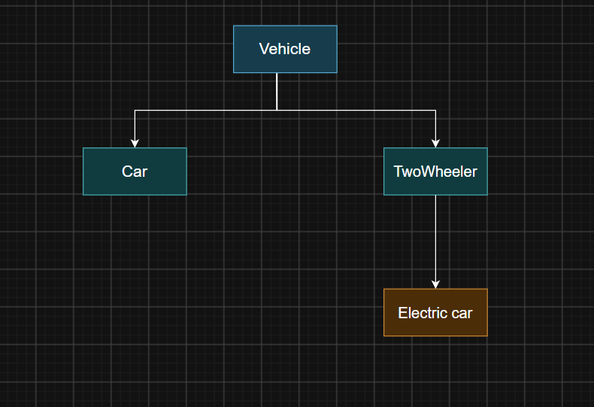
- Type of inheritance used: Single + Multilevel (Hierarchical)
  - TwoWheeler and Car inherit from Vehicle (Hierarchical)
  - ElectricCar inherits from Car (Multilevel)
2. What is Inherited and What is Added
Class | Inherited from Parent | Newly Added
TwoWheeler | regNo, calculateFee() | ratePerHour() = 10
Car | regNo, calculateFee() | ratePerHour() = 30
ElectricCar | Everything from Car + Vehicle | chargingFee() method
3. Use of super
- super(regNo) is used in every subclass constructor to call the parent constructor.
- This avoids repeating the code that sets regNo.
4. Constructor Execution Order (Trace)
When we create new ElectricCar("TN03C3333"):
- ElectricCar constructor is called
- It immediately calls super(regNo) → Car constructor
- Car constructor calls super(regNo) → Vehicle constructor
- Vehicle constructor finishes first
- Then Car constructor finishes
- Finally ElectricCar constructor finishes
Order: Vehicle → Car → ElectricCar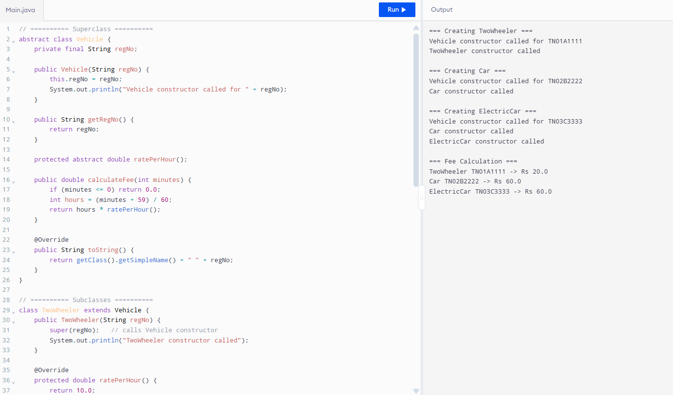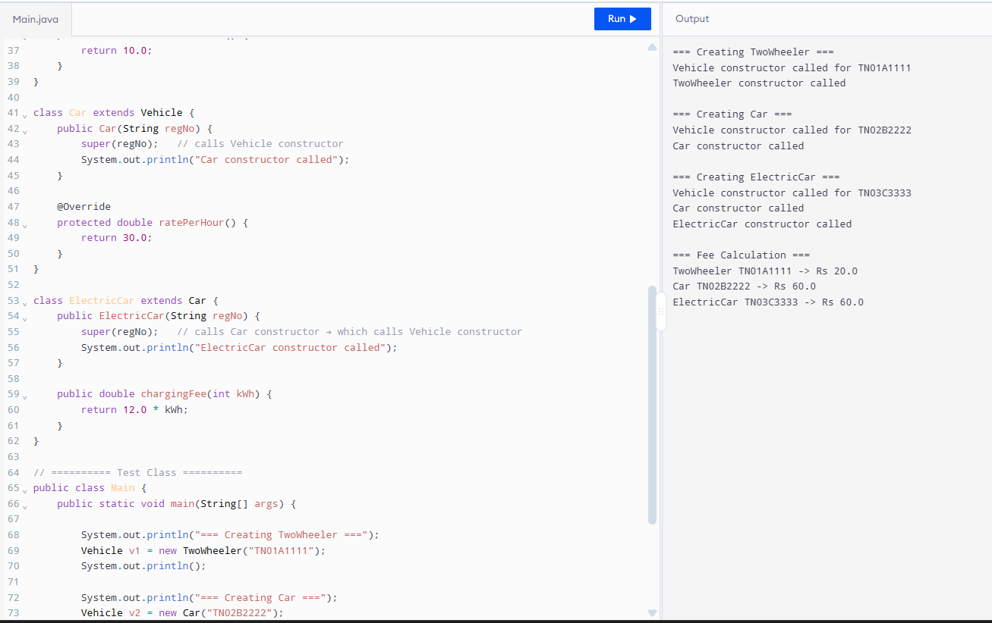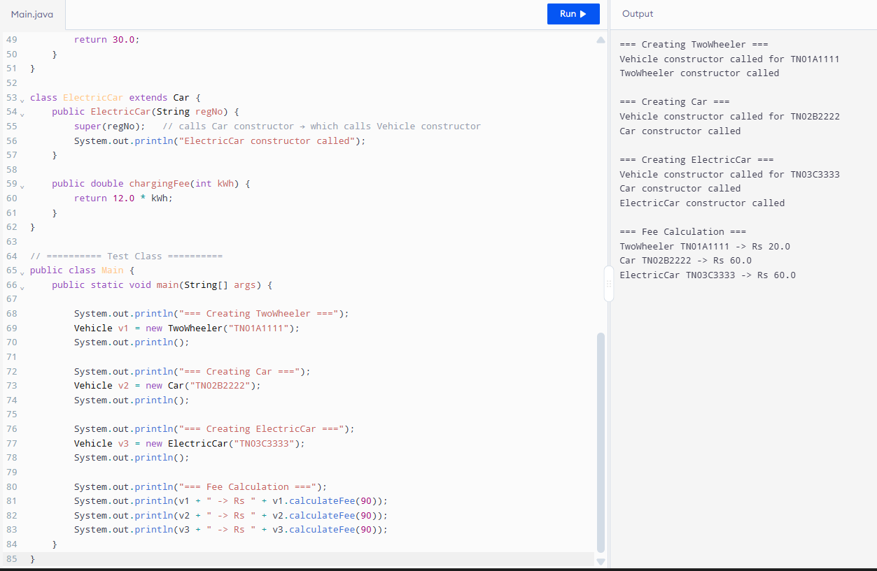
5.Alternative Concept and Complexity Analysis
Current Design (Inheritance – is-a relationship)
Alternative: Composition (has-a)
A single Vehicle class that has a VehicleType object.
Aspect | Inheritance (is-a) | Composition (has-a)
Adding new vehicle type | Create new subclass | Add new VehicleType object
Time to calculate fee | O(1) (dynamic dispatch) | O(1)
Space per vehicle object | Slightly more (vtable) | Slightly less
Code clarity for rates | Very clear | Needs extra class
Multiple inheritance problem | Avoided | Not an issue

